[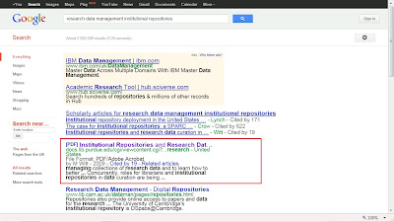](http://3.bp.blogspot.com/-QI63C_iqx2Q/T3ZA1Z61e6I/AAAAAAAACl0/-AnyPkjFi4c/s1600/RDM_in_IRs_google_screenshot.jpg)